**Title:- Game On: Navigating the Dynamics of Video Game Sales**

**Student Name: Avinash Angilikam**

**Student ID: 23037971**

**GitHub Link:** <https://github.com/AVINASH-ANGILIKAM/Game-On-Navigating-the-Dynamics-of-Video-Game-Sales>

**Introduction:**

In this report, we conduct an exploratory analysis of video game sales data to uncover trends, patterns, and insights into the gaming industry. The dataset contains information on video games including their platform, year of release, genre, publisher, and sales figures across different regions.

**Objective:**

The objective of this analysis is to gain a comprehensive understanding of the video game market by exploring various aspects such as sales trends over time, popular genres, top platforms, and the correlation between sales in different regions.

**Abstract:**

The video game industry is a dynamic and rapidly evolving sector, with numerous factors influencing the success of a game. In this report, we aim to analyze a dataset containing information about video game sales to gain insights into sales trends, popular genres, platforms, and publishers. Through descriptive statistics and exploratory data analysis (EDA), we aim to uncover patterns and relationships within the data to provide valuable insights for stakeholders in the gaming industry.

**Summary Statistics:**

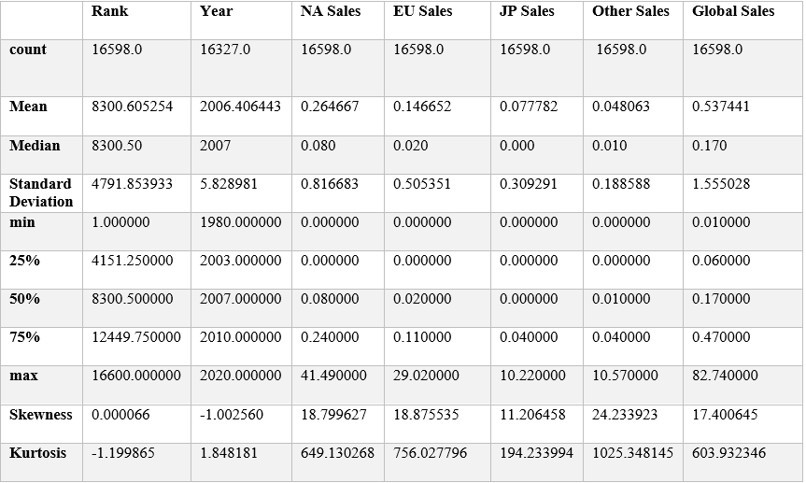

**Exploratory Data Analysis (EDA):**

**1. Scatter Plot of Year vs Global Sales:**

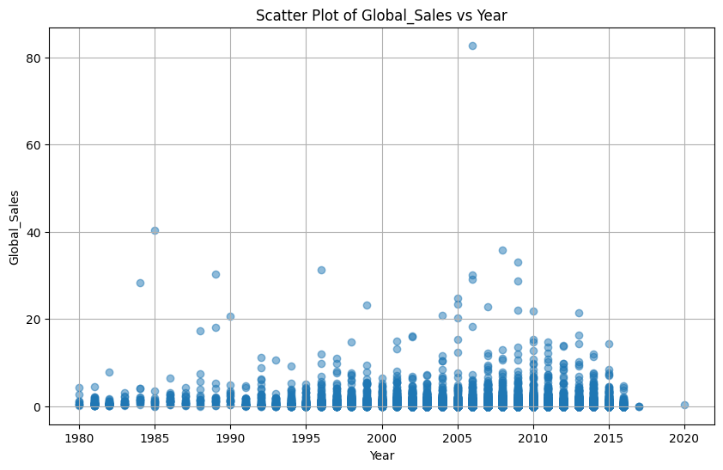

The scatter plot below illustrates the relationship between the release year of video games and their global sales. Each data point represents a video game, with the x-axis representing the release year and the y-axis representing the global sales in millions of units.

The dataset consists of sales data for various years, with global sales figures ranging from 0.01 to 82.74 million units. The mean global sales value is approximately 25.94 million units.

The scatter plot illustrates the distribution of global sales across different release years.

No clear trend is immediately apparent, but it appears that some years have higher global sales than others.

**2. Bar Plot of Top 20 Platforms by Number of Games**:

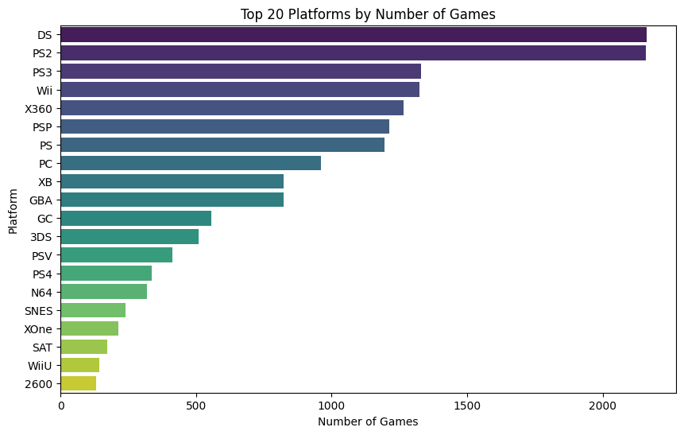

The bar plot illustrates the distribution of games across the top gaming platforms.

Each bar represents a gaming platform, and the height of the bar represents the number of games released on that platform.

The top platforms are identified based on the number of games released, with the top 20 platforms displayed in the plot.

Some platforms have a significantly larger number of games released compared to others.

**3.Correlation Heatmap:**

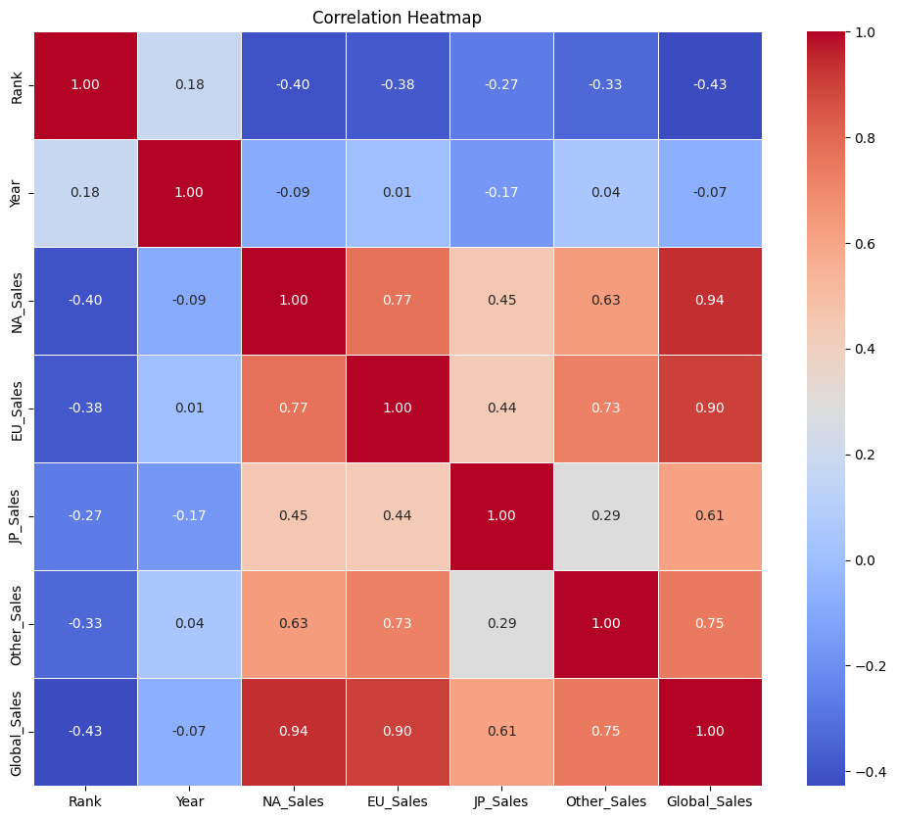

**1. Global Sales vs. Sales in Different Regions:**

Positive Correlation: There is a strong positive correlation between global sales and sales in different regions (North America, Europe, and others).

Weakest Correlation: Sales in Japan have weak relation with Global Sales

Conclusion: Sales in North America and Europe have the strongest positive correlation with global sales, followed by sales in other regions. Sales in Japan have a comparatively weaker correlation with global sales.

**2. Sales in Different Regions:**

Positive Correlation between Regions: There is a positive correlation between sales in different regions.

Strongest Correlation: Sales in Europe (EU_Sales) and North America (NA_Sales) have the strongest positive correlation (0.77).

Weakest Correlation: Sales in Japan (JP_Sales) and Other regions (Other_Sales) have the weakest positive correlation (0.29).

Conclusion: Sales in Europe and North America are closely related, while sales in Japan and other regions show a weaker relationship.

**3. Year of Release vs. Global Sales:**

Weak Negative Correlation: There is a weak negative correlation (-0.07) between the year of release and global sales.

Conclusion: There is a slight tendency for older games to have lower global sales, although the correlation is weak.

**Conclusion:**

This analysis provides valuable insights into the video game industry, highlighting trends and patterns in sales across different regions, platforms, genres, and publishers. Understanding these trends can help stakeholders make informed decisions regarding game development, marketing strategies, and platform partnerships. Further analysis can explore the impact of specific genres, platforms, and publishers on sales performance, providing more actionable insights for industry professionals.

**Recommendations:**

Publishers can focus on genres that have shown consistent popularity over time.

Investment in platforms with a large user base can lead to higher sales.

Considering regional preferences can help tailor marketing strategies for better sales performance.

**Future Work:**

This analysis provides a foundation for further exploration into the video game industry. Future work could involve predictive modeling to forecast sales trends and deeper analysis of factors influencing game sales.

Overall, this report serves as a valuable resource for stakeholders interested in understanding the dynamics of the video game market.